***3)UML Exam Registration System***

**Class diagram**

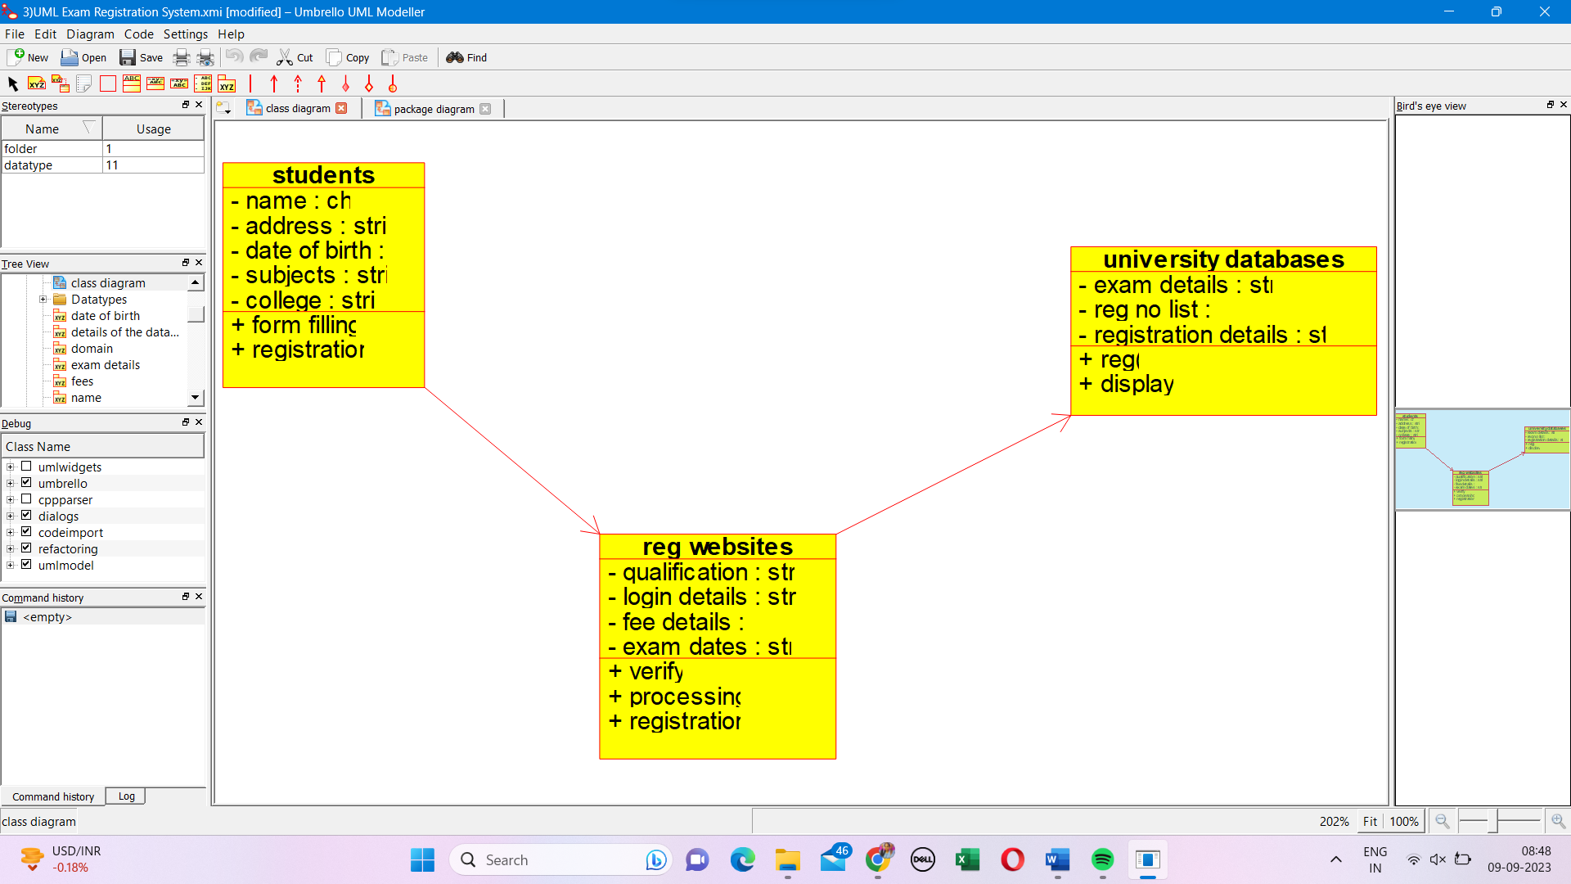

**Package diagram**

